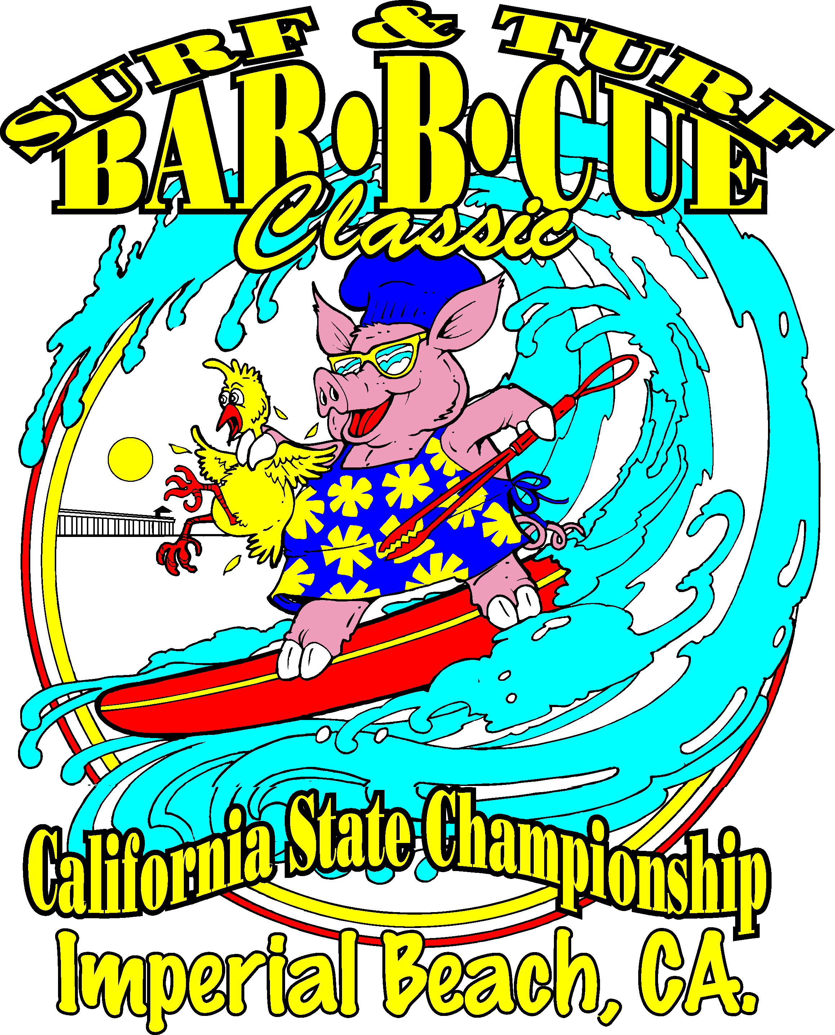
5th Annual Surf & Turf BBQ Imperial Beach California
California’s Longest Running BBQ Contest
Sanctioned by the K.C.B.S.
$2,500 in Cash Prizes

OFFICIAL ENTRY FORM

NAME ____________________________________________________________________________

HOME PHONE __________________________ WORK PHONE _____________________________

ADDRESS/CITY/STATE/ZIP _____________________________________________________________

TEAM NAME ___________________________________ # OF MEMBERS_______________________

TOTAL ENTRY FEE: $200

PLEASE CIRCLE CATEGORIES ENTERED BELOW

CHICKEN PORK RIBS PORK (shoulder or butt) BEEF BRISKET

SEAFOOD ALL 5 CATEGORIES

ENTRY FEE INCLUDES 10 X 20 SPACE FOR FRIDAY NIGHT

Hotel Rooms are available at the Sandcastle Inn (619) 286-2100

INDICATE SIZE: 10 X 20 SPACE___ $30.00 EXTRA FOR 10 X 40 ___
We need to know what Amperage is needed _________

MAKE CHECK PAYABLE TO: Surf & Turf Community Events Inc.
MAIL TO: P.O. Box 96 Imperial Beach, California 91933
For more information call: Gene Goycochea at 619-520-5741 or email gene@cbbqa.com

I AGREE TO ABIDE BY THE RULES AND REGULATIONS OF THE K.C.B.S.
COPIES OF RULES AND REGULATIONS MAILED UPON REQUEST

RELEASE:
WAIVER OF LIABILITY: In consideration of your accepting this entry, I, the undersigned, intending to be legally bound, hereby for myself, my heirs, executors and administrators, waive and release any and all rights and claims for damages against the K.C.B.S. and Surf & Turf Community events inc., and their agents, successors, and assigns, for any and all injuries suffered by me in this event. Further, I hereby grant full permission to the K.C.B.S. and Surf & Turf Community Events Inc., City of Imperial Beach, San Diego Unified Port District and/or agents authorized by them, to use any photographs, videotapes, motion pictures, recordings and any other record of this event for any legitimate purpose.

Signature of Chief Cook Date

